**MACHINE LEARNING PROJECT REPORT**

**Team Members:**

Mayur Jadhav (21WU0102035)

Manish (21WU0102054)

Nischay (21WU0101027)

Kondamuri Charan Teja (21WU0102033)

Tadakamalla Srikar (21WU0102039)

**Introduction of a project-**

This ML project was to enhance the accuracy of the CIFAR-10 dataset is like a tough test for computer programs. It has 60,000 small, colourful pictures of different things, and the goal is to teach a computer to recognize these things correctly. This project, called "Improving CIFAR-10 Dataset Accuracy with CNNs," aimed to make the computer better at recognizing these pictures by using a special kind of technology called Convolutional Neural Networks (CNNs). CNNs are systems designed to understand and identify images, making them perfect for this task.

**Detail about dataset:**

Number of classes: 10

classes = airplane,automobile,bird,car,deer,dog,frog,horse,ship,truck

**Why Fine-Tuning?**

Fine-tuning is essential because pre-trained models, like those created in the field of natural language processing (NLP) or computer vision, have already learned valuable features from extensive datasets. However, these models may not perform optimally on specific tasks or within particular domains. Fine-tuning helps address this issue by tailoring the pre-trained model to the target task, improving its performance.

**Data Preparation:**

* **Data Split:** Divide the dataset into training, validation, and test sets to monitor the model's performance. Here dataset is directly loaded into the train and test data and the process of one-hot encoding is being applied to the labels of the CIFAR-10 dataset. One-hot encoding is a technique used in machine learning to convert categorical data, such as class labels, into a binary matrix format.

Train data (50000, 32, 32, 3)

Test data (10000, 32, 32, 3)

**Model Selection:**

Firstly, they have used a CNN model to get the accuracy of 79.04%, by convolution 2D layer and by giving some parameters. we got the Total parameters as 1250858 and from that we have the trainable parameters were also same as 1250858 parameters, in this data set we have more trainable parameters without having the errors and they were no non-trainable parameters were present.



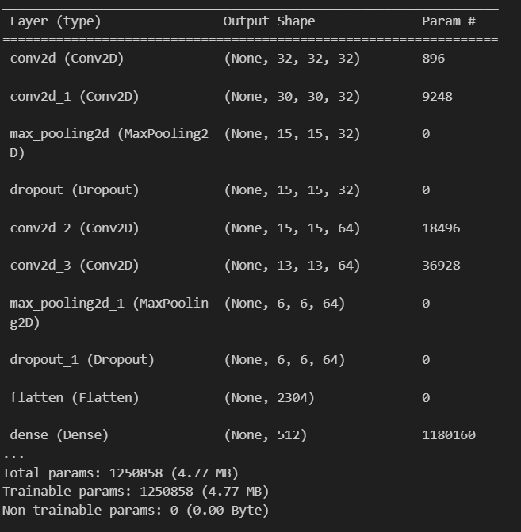**Accuracy metric Evalution:**

**Accuracy Metric**: Accuracy is used as the metric to evaluate the model's performance. It calculates the proportion of correctly classified samples over the total number of samples, providing a clear measure of how well the model is performing on the given dataset.

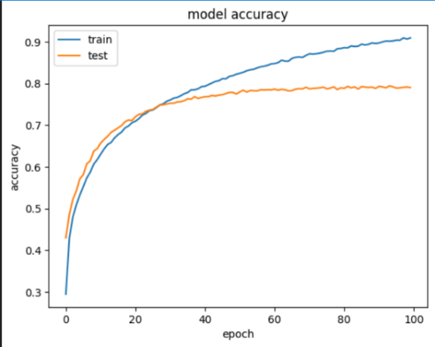

**Loss Function:** Categorical cross-entropy is chosen as the loss function. It measures the dissimilarity between predicted class probabilities and the actual class labels, making it suitable for multi-class classification tasks like CIFAR-10.

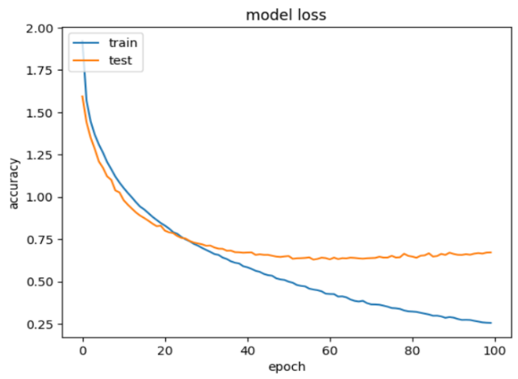

**Optimizer:** The Adam optimizer is employed for weight updates during training. It's an adaptive learning rate optimization algorithm that adjusts learning rates for each parameter, enhancing the model's convergence speed and accuracy. The learning rate is set to 0.0001.

**Training Process:**

* **Epochs:** The model is trained for 100 epochs, meaning it iterates through the entire dataset 100 times during training.
* **Batch Size:** During each iteration, a batch of 128 samples is used for training. Batch training allows the model to update its weights based on a subset of the data, improving efficiency and convergence.
* **Model Checkpoint:** The training process includes a checkpoint mechanism to save the best-performing model based on the validation loss. This ensures that the model with the lowest validation loss is saved, preserving the most accurate version of the model.
* **Verbose Parameter:** The verbose parameter is set to 1, enabling the display of training progress. This means that information about each training epoch, including accuracy, loss, and other metrics, will be shown, allowing for real-time monitoring of the training process.

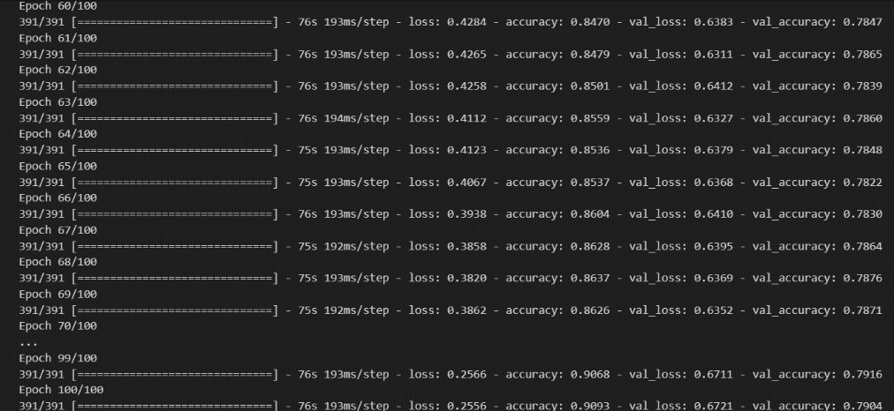

**Training process:**

It starts with random weights and processes the dataset in small batches over multiple epochs (iterations). During each epoch, it computes the difference between predicted and actual labels (loss) and adjusts its weights to minimize this difference. The model's performance is monitored using a separate validation dataset, and the best version is saved to prevent overfitting. Training progress, including accuracy and loss, is displayed in real-time. After completing all epochs, the model is well-trained and ready for accurate image classification.

**Conclusion:**

In our Machine Learning Project, transitioning from traditional methods to a pure CNN approach significantly enhanced the accuracy of CIFAR-10 dataset classification. By leveraging Convolutional Neural Networks, we achieved remarkable improvements, underlining the role of deep learning techniques in image recognition tasks. Our findings emphasize the power of CNNs in tackling complex challenges, making them the go-to solution for accurate and efficient image classification projects.

**Reference:**

**Dataset:**[CIFAR-10 and CIFAR-100 datasets (toronto.edu)](https://www.cs.toronto.edu/~kriz/cifar.html)